Let’s consider the following example data:
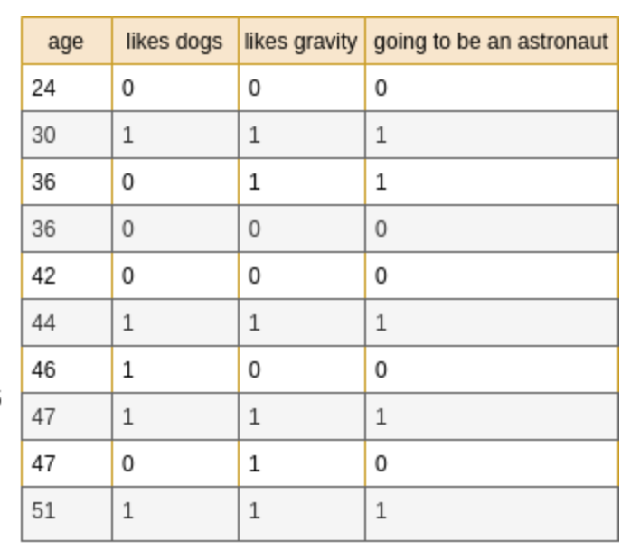
Using this simplified example, we will predict whether a person is going to be an astronaut, depending on their age, whether they like dogs, and whether they like gravity. Before discussing how to construct a decision tree, let’s have a look at the resulting decision tree for our example data.
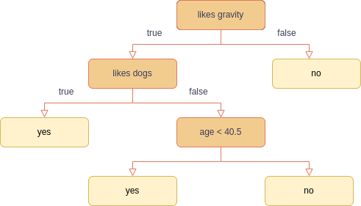

Final decision tree for example data
We can follow the paths to come to a decision. For example, we can see that a person who doesn’t like gravity is not going to be an astronaut, independent of the other features. On the other side, we can also see, that a person who likes gravity and likes dogs is going to be an astronaut independent of the age.

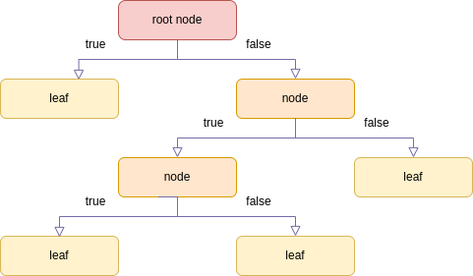

Decision tree illustration
We can also observe, that a decision tree allows us to mix data types. We can use numerical data (‘age’) and categorical data (‘likes dogs’, ‘likes gravity’) in the same tree.

Create a Decision Tree
The most important step in creating a decision tree, is the splitting of the data. We need to find a way to split the data set (D) into two data sets (D_1) and (D_2).

Gini Impurity
The Gini Impurity for a data set D is calculated as follows:
with n = n_1 + n_2 the size of the data set (D) and
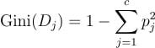
with D_1 and D_2 subsets of D, 𝑝_𝑗 the probability of samples belonging to class 𝑗 at a given node, and 𝑐 the number of classes. The lower the Gini Impurity, the higher is the homogeneity of the node. The Gini Impurity of a pure node is zero. To split a decision tree using Gini Impurity, the following steps need to be performed.
- For each possible split, calculate the Gini Impurity of each child node
- Calculate the Gini Impurity of each split as the weighted average Gini Impurity of child nodes
- Select the split with the lowest value of Gini Impurity
Repeat steps 1–3 until no further split is possible.
To understand this better, let’s have a look at an example.

First Example: Decision Tree with two binary features
Before creating the decision tree for our entire dataset, we will first consider a subset, that only considers two features: ‘likes gravity’ and ‘likes dogs’.
The first thing we have to decide is, which feature is going to be the root node. We do that by predicting the target with only one of the features and then use the feature, that has the lowest Gini Impurity as the root node. That is, in our case we build two shallow trees, with just the root node and two leafs. In the first case we use ‘likes gravity’ as a root node and in the second case ‘likes dogs’. We then calculate the Gini Impurity for both. The trees look like this:

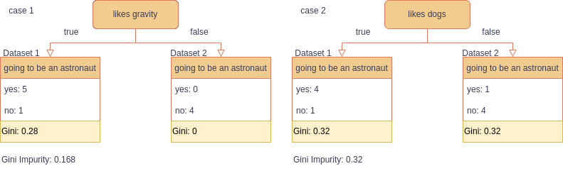
The Gini Impurity for these trees are calculated as follows:
Case 1:
Dataset 1:
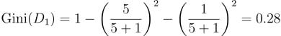
Dataset 2:
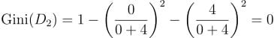
The Gini Impurity is the weighted mean of both:
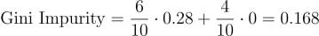
Case 2:
Dataset 1:
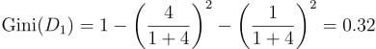
Dataset 2:
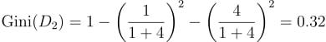
The Gini Impurity is the weighted mean of both:
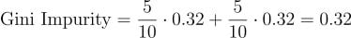
That is, the first case has lower Gini Impurity and is the chosen split. In this simple example, only one feature remains, and we can build the final decision tree.

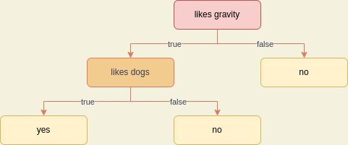

Final Decision Tree considering only the features ‘likes gravity’ and ‘likes dogs’

Second Example: Add a numerical Variable
Until now, we considered only a subset of our data set - the categorical variables. Now we will add the numerical variable ‘age’. The criterion for splitting is the same. We already know the Gini Impurities for ‘likes gravity’ and ‘likes dogs’. The calculation for the Gini Impurity of a numerical variable is similar, however the decision takes more calculations. The following steps need to be done
- Sort the data frame by the numerical variable (‘age’)
- Calculate the mean of neighbouring values
- Calculate the Gini Impurity for all splits for each of these means
This is again our data, sorted by age, and the mean of neighbouring values is given on the left-hand side.

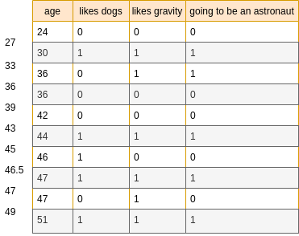
The data set sorted by age. The left-hand side shows the mean of neighbouring values for age.
We then have the following possible splits.
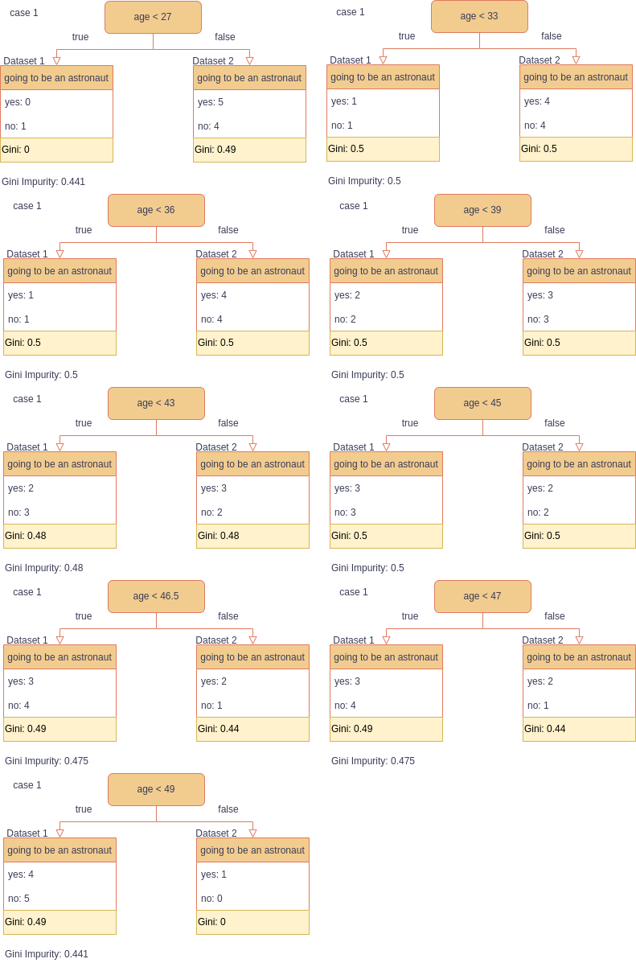
Possible splits for age and their Gini Imputity.
We can see that the Gini Impurity of all possible ‘age’ splits is higher than the one for ‘likes gravity’ and ‘likes dogs’. The lowest Gini Impurity is, when using ‘likes gravity’, i.e. this is our root node and the first split.

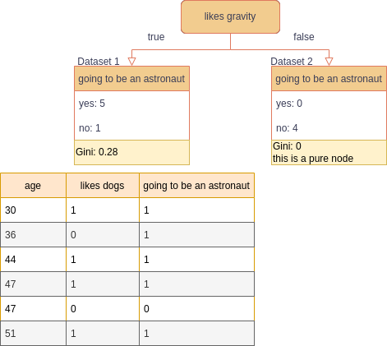
The first split of the tree. ‘likes gravity’ is the root node.
The subset Dataset 2 is already pure, that is, this node is a leaf and no further splitting is necessary. The branch on the left-hand side, Dataset 1 is not pure and can be split further. We do this in the same way as before: We calculate the Gini Impurity for each feature: ‘likes dogs’ and ‘age’.
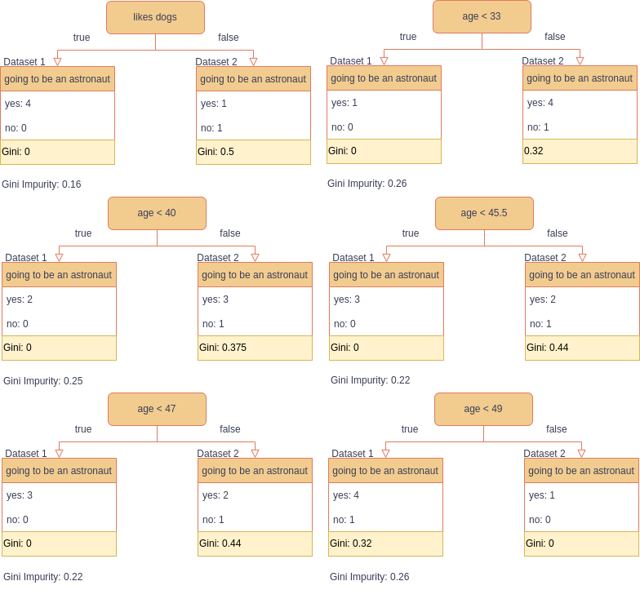
Possible splits for Dataset 2.
We see that the lowest Gini Impurity is given by the split “likes dogs”. We now can build our final tree.

Final Decision Tree.

